Install Python environment on your Windows
1. Click Downloads > Python 3.x.x
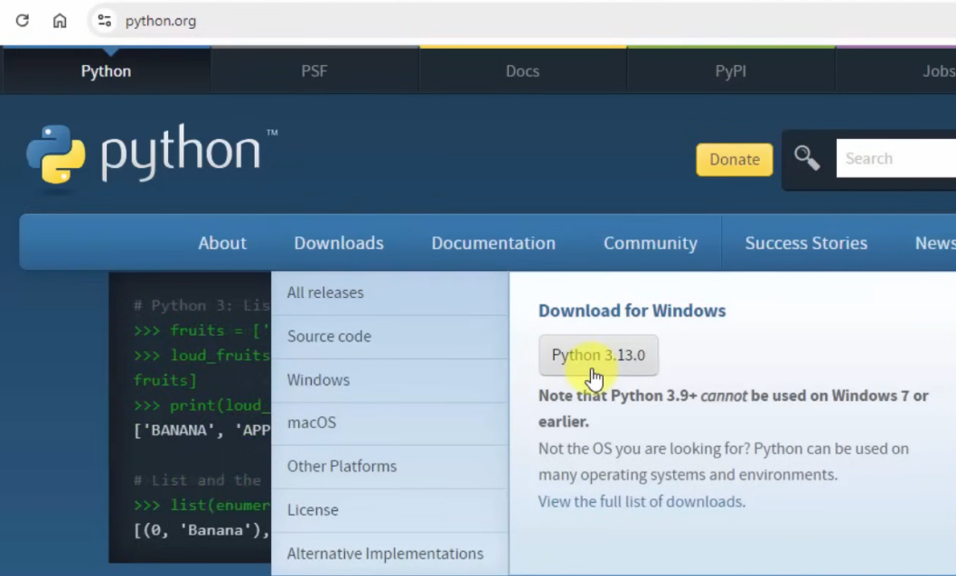

2. Check:
- Use admin privileges when installing py.exe
- Add python.exe to PATH
> Customize installation
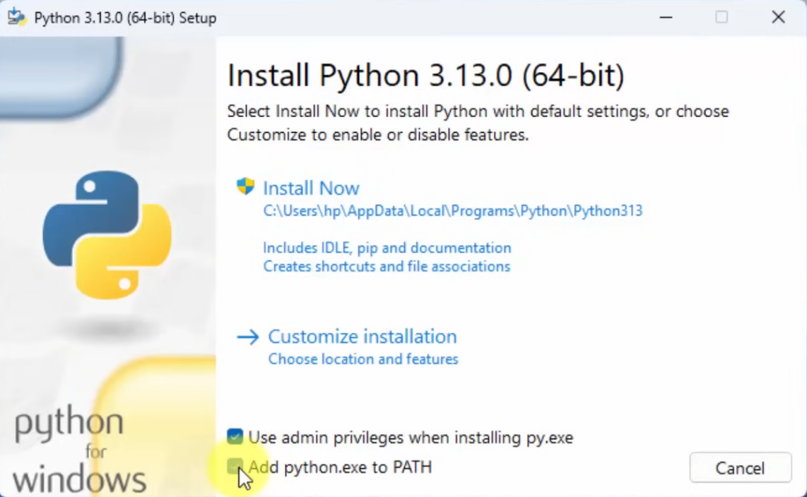

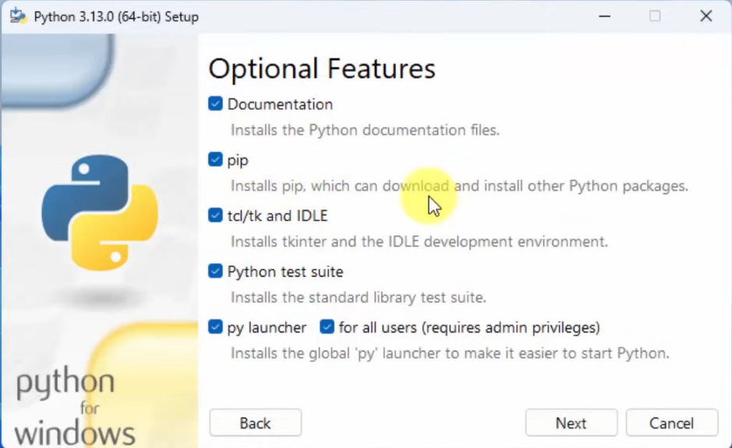
3. Check all > Next

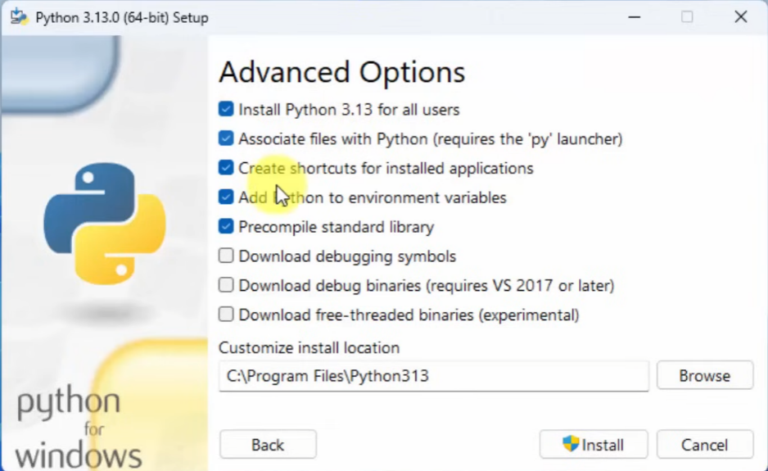
4. Advanced options
Check:
- Install Python 3.13 for all users
- Associate files with Python
- Create shortcuts for installed applications
- Add Python to environment variables
- Precompile standard library
> Install

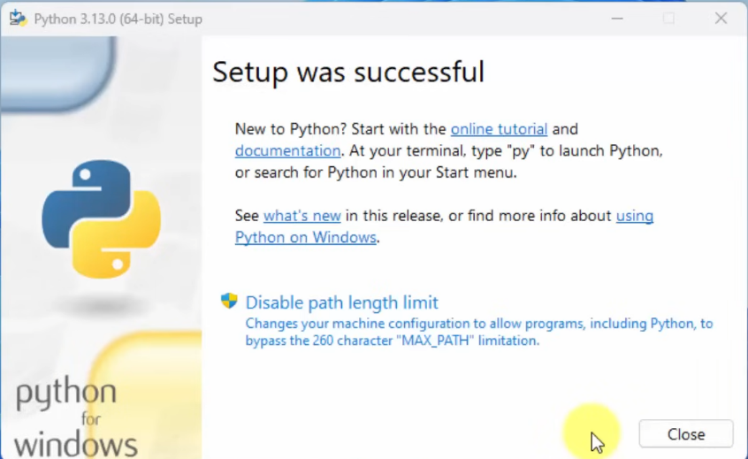
5. Complete installation: click Close

Run Instruction

- **Change directory**
git clone https://github.com/w3ishendt/Paywave-Monitor.git
cd Paywave-Monitor

- **Create a virtual environment**
py -m venv venv
.\venv\Scripts\activate # On Linux Mac OS: source venv/bin/activate
- If errors occurred, run this:
Set-ExecutionPolicy -ExecutionPolicy RemoteSigned -Scope CurrentUser

- **Install dependencies**
pip install -r requirements.txt

- Credentials configuration
In the `config.json`, edit the following credentials:
{
"database": {
"engine": "sql_server",
"table_name": "dbo.tb_PWSettlement",
"sqlite_path": "paywave_test.db"
},

"sql_server": {
"server": "DESKTOP-H23BB0S\\SQLEXPRESS",
"database": "ParkingServerDB",
"username": "sa",
"password": "qwerty7890"
},

"smtp": {
"server": "mail.dtechdigital.com.my",
"port": 465,
"email": "support@dtechdigital.com.my",
"password": "n^;J#O76;Xre"
},

"email": {
"support_recipients": [
"support@dtechdigital.com.my"
],

"customer_recipients": [
"finance@smartparking.com.my"
]
},

"monitor": {
"site_name": "Site Name",
"allowed_lag_days": 1,
"expected_settlement_delay_days": 1,
"minimum_expected_rows": 1,
"recent_gap_check_days": 7,
"alert_cooldown_hours": 24
}
}

- **Run the app**
Place the program in the client site and run:
python main.py

Output (Check your outlook or client/personal email):
